Nuisance bikes and E-scooters
There has been an increase in the use of e-bikes and e-scooters seen in the Town. This has been raised by residents as a ward priority on the My Community Voice Survey. Last month we explained that we would be having regular days of action to tackle the issue and thanks to the reports from the community we have been able to direct patrols to be in the right places at the right times. These days of action include plain clothed officers working with Uniformed in order to try and catch and deal with bikes being ridden dangerously.
On 26th and 27th March, Island Beat Officers along with other member of the Swale CSU conducted an Operation to tackle nuisance bikes and e-scooters in and around Sheerness (Op Fold). Officers were deployed in plain clothes and on foot, as well as in uniform and in cars. This resulted in 2 Sur-Ron bikes, 1 push bike adapted to be a powerful electric bike, 1 quad bike and 2 e-scooters all being seized, having been ridden where they shouldn’t be.
Thanks to the support and reports made from members of public, we were able to be in the right place at the right time to target the issue!
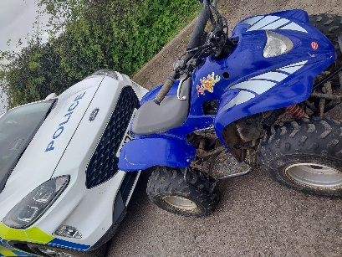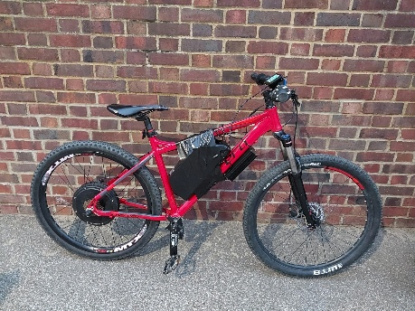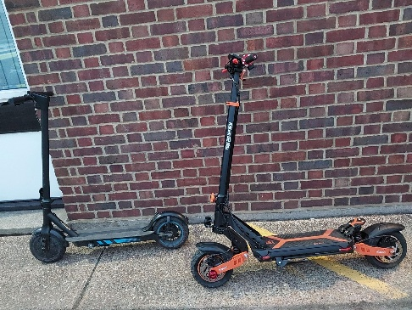
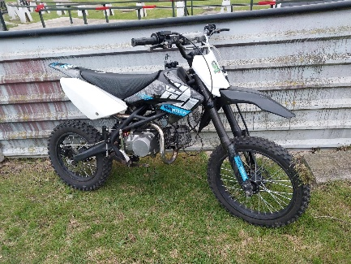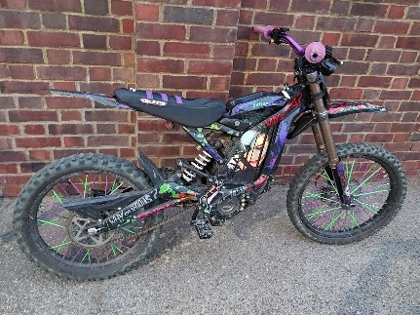

Another Operation to tackle similar issues in Sheerness and the Island in general was conducted on 10th April – OP Nimrod – and resulted in:
6 Stop searches
1 e-scooter seized
1 vehicle seized for driving offences
1 person arrested for Possession with intent to supply class A drugs and other offences.

Catapults and ASB (Anti-Social Behaviour)
We have seen an increase in calls relating to youths with catapults in the local area. This is a nationwide issue and not isolated to Sheerness, however the view of the Police is the same – it will not be tolerated. It causes reckless damage, causes fear to the community and although it is not currently illegal to posses one in public, it will be removed from you should you be found in possession of one in public without a lawful excuse.
Please continue to report any sightings of persons with catapults in public either using 999 if an emergency, 101 or live chat via Kent Police Website. Images have been collated from CCTV and other sources which have been disseminated to local schools and the Child Centred Policing Team. Several have been identified and enquiries are ongoing. Multiple catapults have been seized but the issue continues. Of concern is the fact that wildlife is being targeted, with reports of injuries to birds and other animals from potential use of catapults.
During the Half Term/Easter Holiday break it is usual for calls relating to anti-social behaviour to increase, and so on 8th April a dispersal order was put in place for 48 hours in the town. This gives Officers the power to instruct a person to leave a locality and not return within 48 hours if they are causing ASB, or it is believed that they will likely cause ASB if allowed to remain in the area. This assisted in seeing a drop in reports of ASB for the latter part of the Easter Holidays!
Winstanley Road house fire
On 5th April, Police came across a house on fire in Winstanley Road, Sheerness. Kent Fire and Rescue were quickly on scene and houses nearby evacuated, thankfully there were no casualties but substantial damage was caused. It was deemed there were no suspicious circumstances, and Social Media reports suggest that the local community has rallied around those that were involved and have provided them with items to keep them going in their time of need. Sheerness really is a close knit community and its great to hear residents coming together to look out for each other!
Alma Road Incident
On Thursday 16 April, Kent Police were called to a disturbance inside a private property in Alma Road. Officers attended and a man in his 50s was located with an injury consistent with a stab wound. A short time later he was confirmed to be deceased and his next of kin were informed. A 32 year old man and a 34 year old woman, both from Sheerness have been arrested on suspicion of murder and at the time of writing are still currently in custody.
A cordon remains at the property while enquiries into the incident are ongoing.
Investigators are appealing to any witnesses who have not yet spoken to the police to contact them.
Residents with private CCTV and motorists with dashcam are also asked to check for relevant footage. Anyone with information should call 01795 419119, quoting reference 46/60312/26. Incidents like this are rare but can cause a large amount of anxiety and fear within a community, especially the presence of a lot of Police. For reassurance and to keep up to date with what’s happening in the area, check the Kent Police website for the most recent information.

Upcoming surgeries and events:
PC 12329 HONESS: ‘Drop in’ surgery on Tuesday 12th May at Sheerness Town Council offices – 10:00 – 12:00 hours

