Incidents of note/Good Work Stories

The Nutcracker
We are sure many people will have seen the well documented theft of the Nutcracker Statue from outside Luke Allum Funeral Directors. Following it being reported to Kent Police, 2 males were arrested and in custody the day after the theft. Both have been charged and bailed to court for their part in this despicable incident. Unfortunately the Nutcracker has not been found so we would appeal for any information as to its’ whereabouts to return it to its rightful owner.
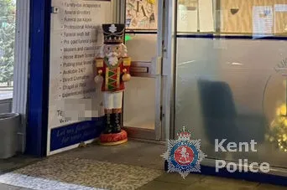

A Very Busy Friday…
On the same day as the Nutcracker arrests another 2 males were arrested after being located for multiple shopliftings in Sheerness. Between the 4 offenders 21 Charges were secured with 2 of the offenders remanded to court. Unfortunately the Courts decided against sending any of the suspects to prison despite their offending history and 1 has since started re-offending as is back on our list of outstanding suspects…

Sheerness Christmas Market
PC Hewes and PC Savage were joined by PCSO’s Dry, Linge and Ansbro at the Sheerness Christmas Market on 6th December. Hundreds of local residents came down to enjoy the festivities and there was a lot of engagement between the Police and members of the public, councillors and even the Local MP. A huge well done to Becci and Zoe for arranging a fantastic, well run event which allowed us as Police concentrate on engaging with local residents and we hope they managed to enjoy a nice relaxing glass of wine once the event had finished.
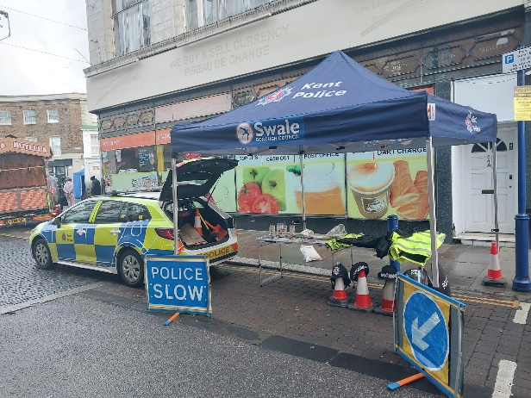

Joint Working With The Marine Unit
PC Hewes spent a couple of shifts working with the Kent Police Search and Marine Unit finding out what help and support each department can offer to each other. The SMU have recently acquired 2 Jet Skis and are undergoing the relevant training in readiness for the next summer season. Plans are already afoot to run joint operations next year to tackle reports of nuisance jet skis along the seafront
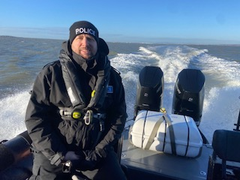
Local Officers Supporting Local Organisations and Groups
When not tackling crime in Sheerness PC Hewes and PC Honess also attend community engagements. This month PC Hewes attended Masters House for the last “Island 2 Island” event, where members of the Caribbean Community on Sheppey meet up. PC Honess attended the Dementia Café and engaged with the service users there. If you are holding a community event of meeting and would like a local officer to attend, please get in touch and where possible we will try to attend.
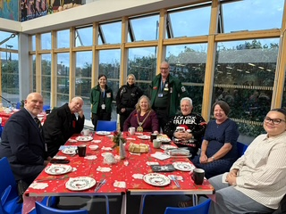
Reduction in reported Crime and ASB
We are pleased to report a drop in reported crime and ASB across Sheerness. In figures up to the end of October reported crime and ASB is down by nearly 13%. The amount of serious crimes has also dropped. Kent police use a “Harm Score” - scoring each crime dependent on the amount of harm caused to the victim, for example a GBH scores considerably more than a Shoplifting. The current Harm Score for Sheerness is 28% lower than the start of the year.
Merry Christmas!
PC Hewes and PC Honess would like to wish everyone a Merry Christmas! Enjoy the festive season, time with friends and family and all the food and drink. For those who aren’t as fortunate as some, remember there are fantastic organisations out there who can provide support. Please remember to drink responsibly and that its always better to go home in a taxi instead of a Police Car or Ambulance!

Upcoming Surgeries

PC Hewes will be holding a surgery on Friday 16th January 1000-1200 at Sheppey Gateway.

PC Honess will be holding a surgery on Tuesday 25th November - 13:00 - 15:00 at Islandworks, Dockyard Church

Your Local Beat Officers For Sheerness Are:
PC 12329 Alison Honess & PC 13666 Richard Hewes


